For New Hires (especially CRCs/research staff):
- Useful website: https://www.hr.upenn.edu/PennHR/learn-grow/orientation-and-onboarding

- Go to Penn Onboarding Center at 3425 Walnut Street: https://www.solutioncenter.upenn.edu/home/onboard

- Get a PennCard at 3601 Walnut Street, 2nd Floor (https://cms.business-services.upenn.edu/penncard/)

- Get a HUP ID card (contact Stephanie Johnson for details). ID office is on ground floor of Gates Pavilion:
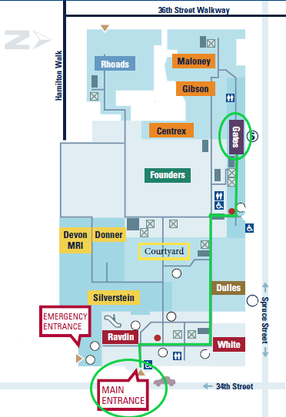

- If needed, get a PAH ID card (contact: Donna Lesner).

- Log in to Home | Learning (myworkday.com)and complete the profiler survey.
  - Then complete the required courses that have now been assigned to you in Home | Learning (myworkday.com).
    - Tip: some of the courses contain audio, so you may want to bring earphones.
  - Make sure to complete "Protecting Patient Information (HIPAA) | Learning (myworkday.com)” (Course HS.30006.ITEM.HIPAA_Y19)
  - Complete “One HUP Building Orientation/Life Safety eLearning” (Course HS.50025.ITEM.HE1BOLSEL)
  - If applicable, complete “Shipping of Hazardous Materials and Dangerous Goods for Laboratory Staff - EHRS –Online” (Course UP.83015.ITEM.SILIPOL)

- Request access to Oto department’s shared drive (and any specific sub-folders you’ll need to use [for example, “OTO RESEARCH” folder]) from Chris Binder.

- Do CITI (Collaborative Institutional Training Initiative) training: citiprogram.org
  - Complete the “Protection of Human Subjects” (biomedical research basics) course
    - I:\OTO RESEARCH\Forms, templates, training\CITI\How to access CITI Training.pdf
    - I:\OTO RESEARCH\Forms, templates, training\CITI\How to transfer CITI from other institution.pdf
    - I:\OTO RESEARCH\Forms, templates, training\CITI\Problems with CITI.pdf
  - Complete the “Good Clinical Practice” course (recertify once in 3 years) I:\OTO RESEARCH\Forms, templates, training\CITI\Clinical Research Staff_GCP Instructions.pdf
    - CITI Good Clinical Practice (GCP) eLearning Module - OCR
    - Good Clinical Practice (GCP) Simulation Renewal | Learning (myworkday.com)
  - Complete the “HIPAA Privacy” course (recertify annually)
Protecting Patient Information (HIPAA) | Learning (myworkday.com)
  - Forward completion reports and/or certificates to Prannda Sharma.

- Do Penn CR (clinical research) OnboardingProgram: Penn Clinical Research (CR) Onboarding - OCR | Learning (myworkday.com)
  - To request access to the training: https://redcap.med.upenn.edu/surveys/?s=AWXR9H8AHK
  - Complete the training (For help or problems accessing the CR training, contact Marisa Cinousis.)
  - Then sign up for CRSPR (Clinical Research Staff Registry & Portal)

- Request PennChart (Epic EMR) access via Home | Learning (myworkday.com)
  - Complete "PennChart Clinical View Only" tutorial (COURSE HS.20001.ITEM.ISEPCVIEWONLY)
  - Register for in-person trainings:
    - "PennChart Training for Research Coordinators | Learning (myworkday.com)" class (COURSE UP.40009.ITEM.HSRWS148) and
    - “PennChart Training for Research Billers | Learning (myworkday.com)” class (COURSE UP.40009.ITEM.HSRWS171)
  - Once training is complete, request addition to relevant protocols in PennChart (email Katie Linder with CRC name, protocol #, and RBN)

- Register for PennCTMS (Clinical Trial Management System; formerly called Velos) training:
  - Home | Learning (myworkday.com): “PennCTMS Fundamentals Hands-On Training” (COURSE UP.40009.ITEM.HSRWS147)
  - Feel free to list Prannda Sharma as your “Supervisor/Penn Sponsor” on the access request form.

- Request access to HUP OR, PCAM OR, HUP East/Pavilion, and/or PCAM 3S ENT Clinic (if needed).
  - For CRCs, faculty, staff: Stephanie Johnson
  - For residents/fellows: Bonnie Rosen

- Request access to REDCap (if needed): https://somapps.med.upenn.edu/forms/somis/view.php?id=15207

- Attend a Penn New Staff Orientation session (optional, but recommended)
  - To register, email mkuhnel@upenn.edu

- Penn Human Resources: https://www.hr.upenn.edu/PennHR
- Your benefits, pay stubs, time off, etc.: https://www.myworkday.com/upenn/d/home.htmld

- Useful research-related resources:
  - Penn Manual for Clinical Research: Study Start-Finish guide
  - Penn’s Office of Clinical Research: https://www.med.upenn.edu/ocr/
  - Penn’s Institutional Review Board (IRB): https://irb.upenn.edu/
  - Penn’s Cancer Center Research Board: http://www.ctsrmc.org/
  - U.S. Food and Drug Administration (FDA): https://www.fda.gov/home
  - ClinicalTrials.gov
    - ClinicalTrials.gov’s Protocol Registration and Results System: https://register.clinicaltrials.gov/prs/app/template/Home.vm?ts=4&cx=-cnls5z
    - (For questions/help regarding clinicaltrials.gov, contact Tyrone Quarterman)
  - REDCap: https://redcap.med.upenn.edu/
    - For REDCap help: https://somapps.med.upenn.edu/forms/somis/view.php?id=15207
    - Non-password related questions: redcap@mail.med.upenn.edu

